<!DOCTYPE html>

<html lang="en">

<head>

    <meta charset="UTF-8">

    <meta name="viewport" content="width=device-width, initial-scale=1.0">

    <title>Flipkart RealMe</title>

</head>

<body>

    <img src="realmepic.png" width=100%/>

</body>

</html>

Page 1:

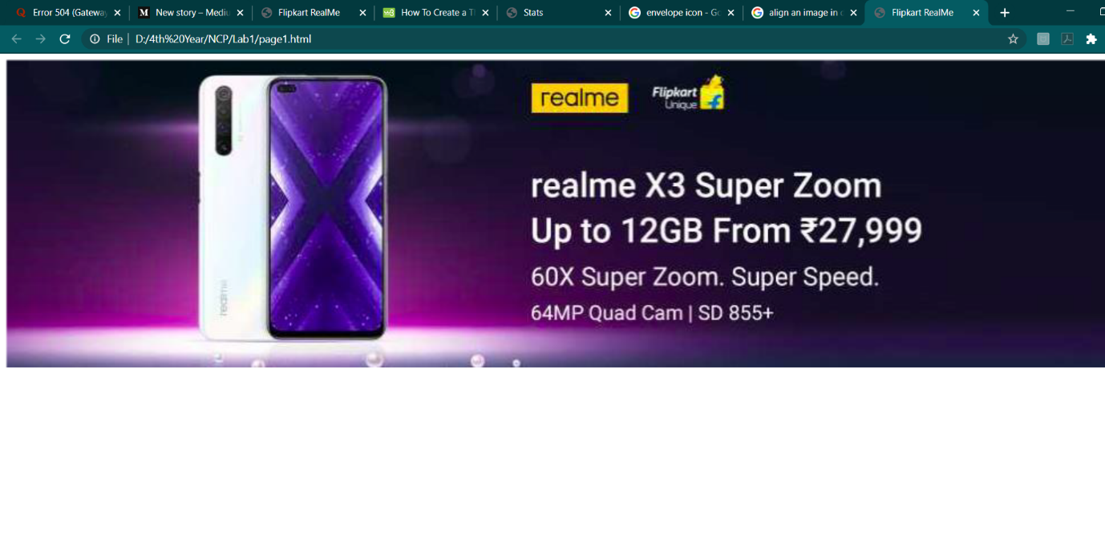

Page 2:

<!DOCTYPE html>

<html lang="en">

<head>

    <meta charset="UTF-8">

    <meta name="viewport" content="width=device-width, initial-scale=1.0">

    <title>Stats</title>

    <style>

        p{

*font-size*: small;

        }

        .col{

*float*:left;

*margin-right*: 6px;;

*border*: 1px solid beige;

*padding*:1em;

*position*:relative;

*height*:70vh;

        }

        #main{

*width*:40%;

        }

        img{

*width*:100%;

        }

        .row{

*height*:80%;

        }

        .row p{

*position*: absolute;

*bottom*:0;

        }

    </style>

</head>

<body>

    <div>

        <div class="title-card">

            <h2>Welcome to the BBC</h2>

            <p>Friday, 23 December</p>

        </div>

       <div class="row">

           <div class="col" id="main"><img src="sportsimage1.jfif"><h4>Sports Headlines</h4><p>Sports Date</p></div>

           <div class="col"><img src="starsimage.jfif"><h6>Stars Headlines</h6><p>Stars Date</p></div>

           <div class="col"><img src="mayanimage.jfif"><h6>Mayan Headlines</h6><p>Mayan Date</p></div>

       </div>

        </div>

    </div>

</body>

</html>

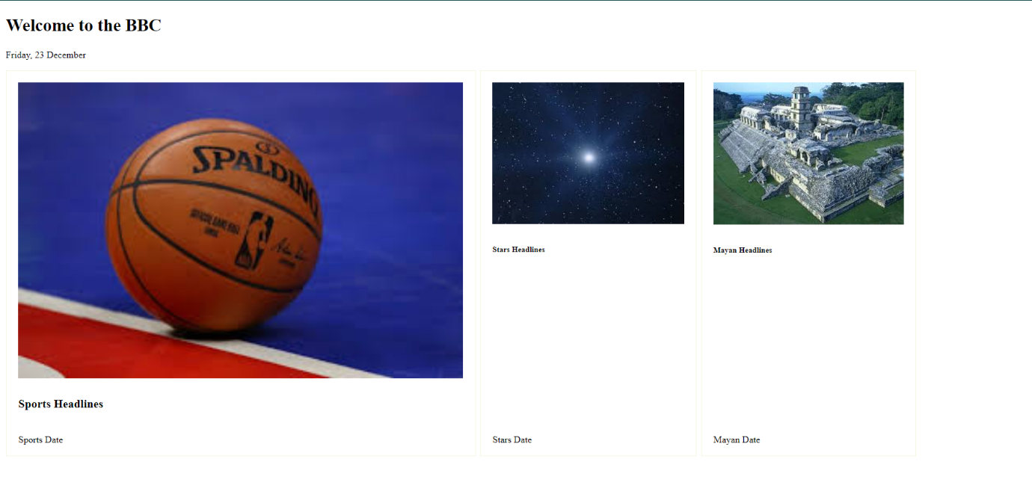

Page 3:

<!DOCTYPE html>

<html lang="en">

<head>

    <meta charset="UTF-8">

    <meta name="viewport" content="width=device-width, initial-scale=1.0">

    <title>Document</title>

    <style>

        .header {

*text-align*: center;

*background-color*: lightskyblue;

*width*: 60%;

*margin-left*: 20%;

        }

        .header h4 {

*font-family*: monospace;

*color*: black;

        }

        #email {

*font-family*: sans-serif;

*color*: white;

        }

        #magic {

*font-family*: cursive;

*color*: black;

        }

        .bodyclass{

*width*: 60%;

*height*:60%;

*margin-left*: 20%;

*margin-bottom*:2em;

        }

        .intro {

*width*: 60%;

*margin*: 2em;

*margin-left*: 20%;

*padding*: 1em;

*background-color*: beige;

        }

        .intro h4 {

*font-family*: 'Gill Sans', 'Gill Sans MT', Calibri, 'Trebuchet MS', sans-serif;

        }

        .col {

*float*: left;

*width*: 50%;

*background-color*: beige;

        }

        .col img {

*width*: 80%;

*height*: 300px;

*margin-right*: 2em;

*margin-left*: 2em;

        }

        .footer {

*background-color*: red;

*width*: 60%;

*margin-left*: 20%;

*margin-top*:2rem;

*padding-bottom*:2em;

*padding-top*:2em;

*text-align*:center;

*color*:white;

        }

    </style>

</head>

<body>

    <div class="header">

        <img src="envelopepic.png" alt="env">

        <h4>Creative</h4>

        <h2><span id="email">email </span> <span id="magic">magic</span></h2>

    </div>

    <div class="intro">

        <h4>Placeholder Heading</h4>

        <p> Welcome to this brochure that has been designed by designers for the purpose of the Net-Centric Programming

            Course as a HTML Practice Session</p>

    </div>

    <div class="bodyclass">

        <div class="col">

            <div class="img"><img src="sportsimage1.jfif"></div>

            <p>Basketball greeting cards are some of the most wonderful for sports enthusiasts and game fans all over

                the globe</p>

        </div>

        <div class="col">

            <div class="img"></div><img src="starsimage.jfif">

            <p>Information about various astronomical discoveries mailed to you at the low price of USD 50. Postcards

                from the stars has you covered with pictures of galaxies and battleships.</p>

        </div>

    </div>

    <div class="footer">

        <h4>FOOTER</h4>

    </div>

</body>

</html>

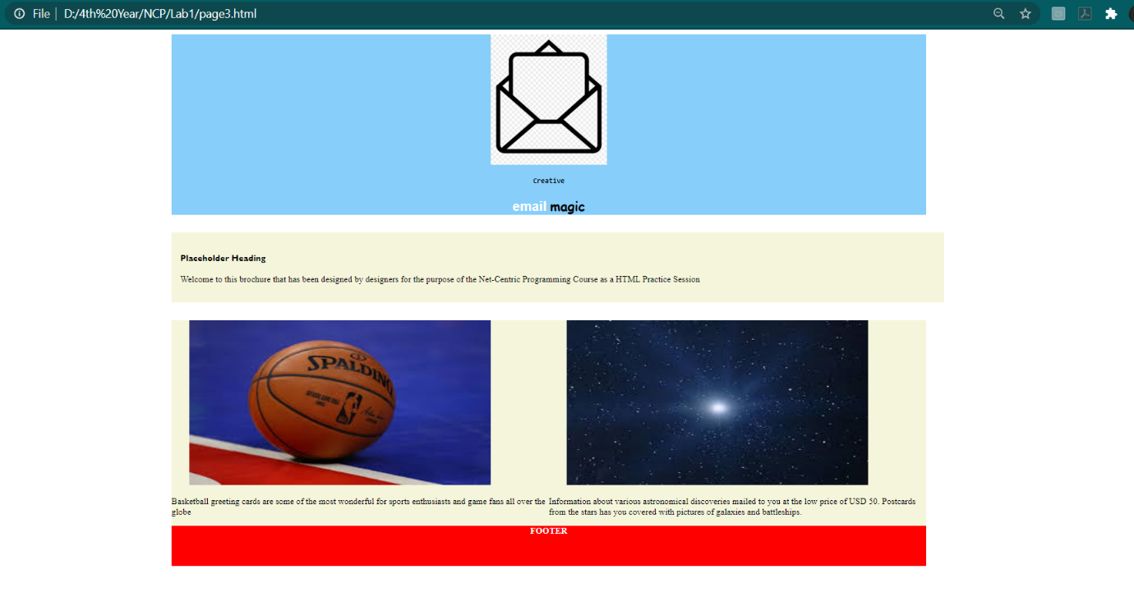

Page 4:

<!DOCTYPE html>

<html lang="en">

<head>

    <meta charset="UTF-8">

    <meta name="viewport" content="width=device-width, initial-scale=1.0">

    <title>Table of Celestial Bodies</title>

    <style>

        table{

*border*:1.5px solid black;

        }

        td, th{

*border*:1.5px solid black;

*text-align*: center;

        }

        a{

*text-decoration*: none;

*color*: blue;

        }

        th{

*background-color*: lightslategray;

        }

    </style>

</head>

<body>

    <table cellpadding="5" cellspacing="0">

        <tr>

            <th colspan="2"></th>

            <th>Name</th>

            <th>Mass(10<sup>24</sup>)</th>

            <th>Diameter(km)</th>

            <th>Density(kg/m<sup>3</sup>)</th>

            <th>Gravity(m/s<sup>2</sup>)</th>

            <th>Length of day(hours)</th>

            <th>Distance from Sun(10<sup>6</sup> km)</th>

            <th>Mean temperature (C)</th>

            <th>Number of moons</th>

            <th>Notes</th>

        </tr>

        <tr>

            <td colspan="2" rowspan="2">Terrestrial Planets</td>

            <td>Mercury</td>

            <td>0.330</td>

            <td>4,879</td>

            <td>5427</td>

            <td>3.7</td>

            <td>4222.6</td>

            <td>57.9</td>

            <td>167</td>

            <td>0</td>

            <td>Closest to the Sun</td>

        </tr>

        <tr>

            <td>Venus</td>

            <td>4.87</td>

            <td>12,104</td>

            <td>5243</td>

            <td>8.9</td>

            <td>2802.0</td>

            <td>108.2</td>

            <td>464</td>

            <td>0</td>

            <td></td>

        </tr>

        <tr>

            <td colspan="1" rowspan="2">Jovian Planets</td>

            <td>Gas Giants</td>

            <td>Jupiter</td>

            <td>1898</td>

            <td>142,984</td>

            <td>1326</td>

            <td>23.1</td>

            <td>9.9</td>

            <td>778.6</td>

            <td>-110</td>

            <td>67</td>

            <td>Largest Planet</td>

        </tr>

        <tr>

            <td>Ice Giants</td>

            <td>Uranus</td>

            <td>568</td>

            <td>120,536</td>

            <td>687</td>

            <td>9.0</td>

            <td>10.7</td>

            <td>1433.5</td>

            <td>-140</td>

            <td>62</td>

            <td></td>

        </tr>

        <tr>

            <td>Dwarf Planets</td>

            <td>Pluto</td>

            <td>0.0146</td>

            <td>2,370</td>

            <td>2095</td>

            <td>0.7</td>

            <td>153.3</td>

            <td>5906.4</td>

            <td>-225</td>

            <td>5</td>

            <td>Declassified as a planet in 2006, but this <a href="https://www.scientificamerican.com/article/is-pluto-a-planet/">remains controversial</a></td>

        </tr>

    </table>

</body>

</html>

